**Variable**

* It is an entity that may vary during execution of program called as variable.
* Variable is a name which is associated with a value that can be changed.

**Guidelines for declaring variables**

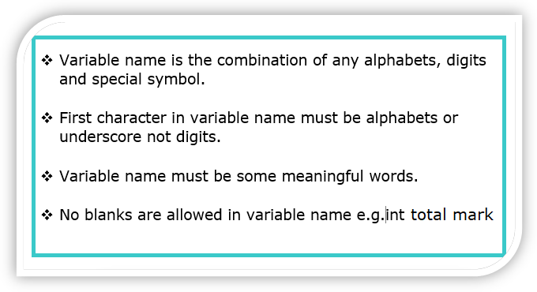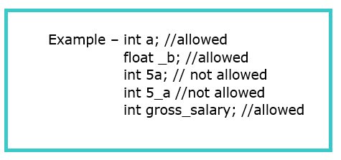

**Note**- Variable is declared followed by semi-colon (;)

There are two types of variable as

1. Global variable
2. Local variable

1. Global variable

* It is defined outside of method but inside the class called global variable.
* It is called as **instance variable.**
* How to **declare and initialize** the global variable?

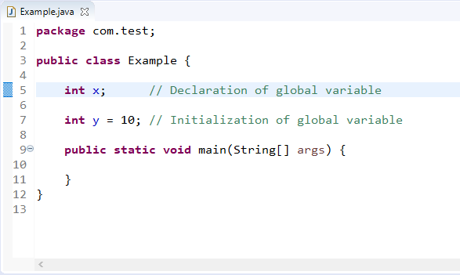

* In this example, we have declared x variable as globally, outside of the method.
* It is initialized automatically by JVM and default value is 0.
* Global variables are stored in **heap area**.
* Each instance (objects) of class has its own copy of instance variable.
* Scope is anywhere in the class.

**Note**- Static keyword is applied to global variable and it will become a static variable.

1. Local variable

* It is declared inside method body called as local variable.
* It is also declared in constructor or block.
* How to **declare & Initialize** the local variable?

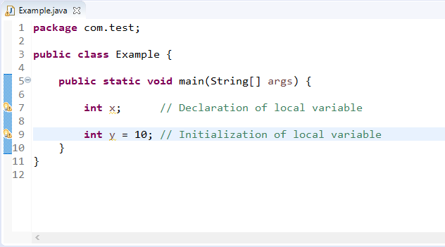

* Scope is within the method, constructor and block only.
* Local variable is also declared in constructor.
* It does not initialized automatically.
* Local variables are stored in stack area.

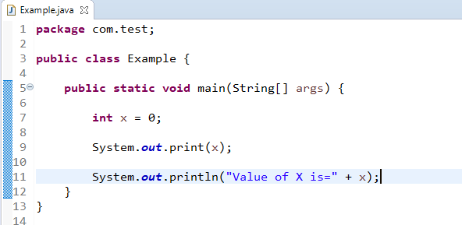

* In this example, we are printing the value of variable by using two ways.

1. System.out.print(x); // Here passing variable x.
2. System.out.println (“Value of X is=”+x); // Here we are writing message in double quotes then passing variable x.

Both statements indicates that output is 0.

* If you are trying to use local variable without initialization then we will get compile time error.

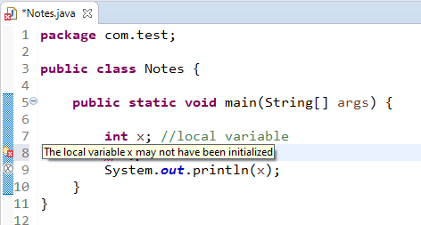

**Note**- Static keyword is not applied to local variable.

**How to access the global variable outside of class.**

Step-1 Create another class.

Step-2 Create the object of that class.

Step-3 Call the variable

**public** **class** GlobalDemo {

**int** x ; //declaration of global variable

**int** y=10; //initalization of global variable

**public** **static** **void** main(String[] args) {

GlobalDemo globalDemo= **new** GlobalDemo(); //this is the way to create the object of class

//globalDemo this is the object name

System.**out**.println("value of x variable>>"+globalDemo.x); //concat, to join

// //how to print the value of variable- objectname.variablename

System.**out**.println("value of y variable is>>"+globalDemo.y);

}

}

**public** **class** Test {

**public** **static** **void** main(String[] args) {

GlobalDemo globalDemo= **new** GlobalDemo();

System.**out**.println(globalDemo.y);

}

}

Output

value of y variable is>>10